Algorithms and Data Structures

# Question 3

BST: 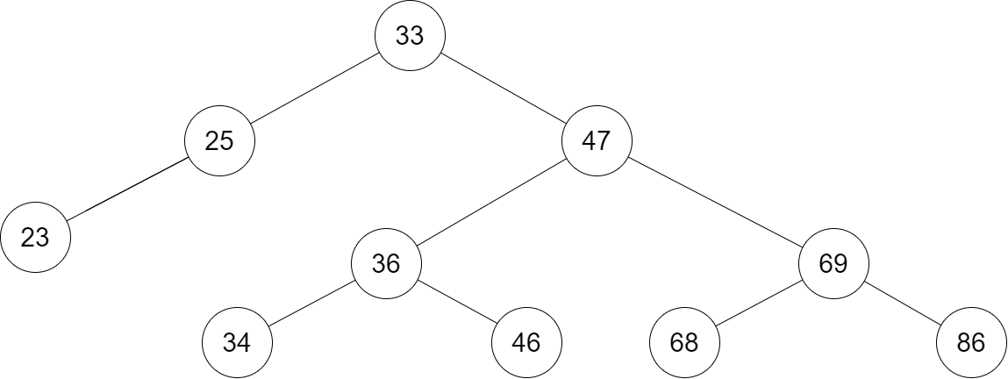

Pre-order sequence: 33, 25, 23, 47, 36, 34, 46, 69, 68, 86